**Docker Task**

Installed docker on EC2 and explored docker commands (docker images, containers, volumes, network)

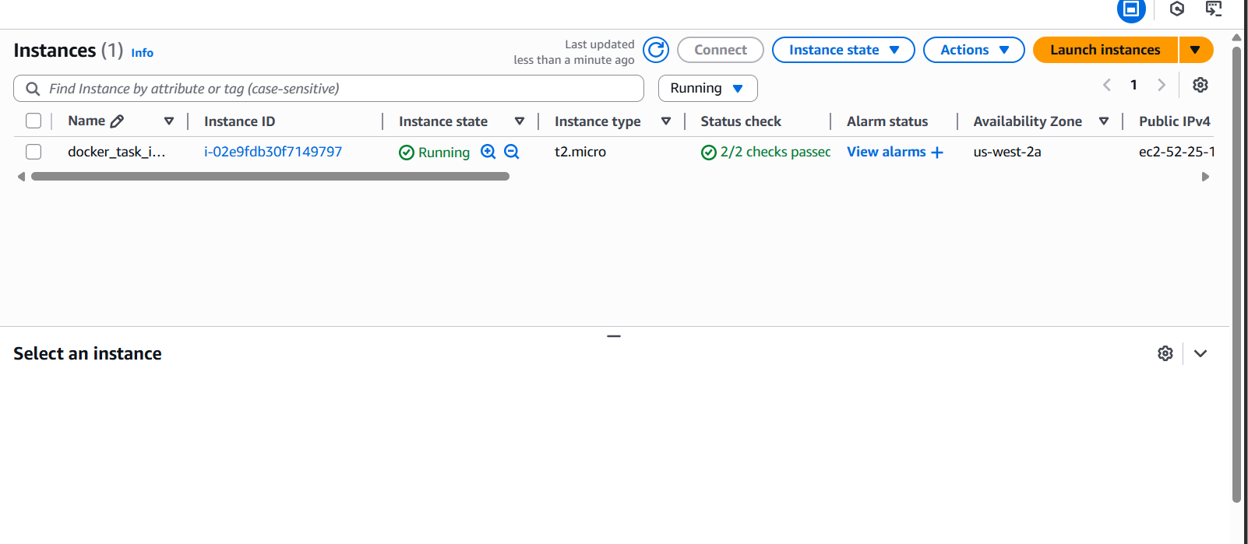

Docker Images

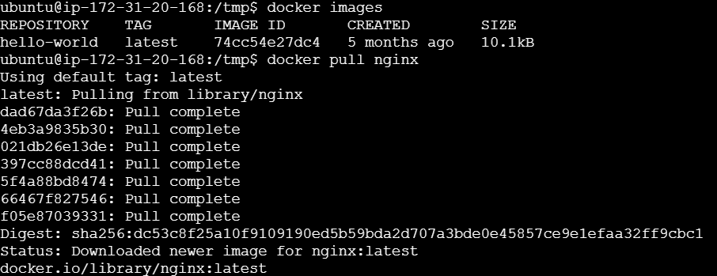

Docker Containers



Docker Volumes

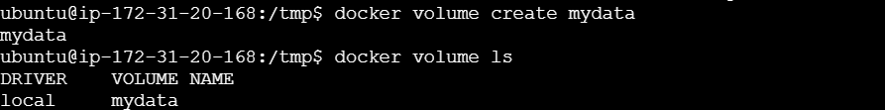

Docker Network

